EXPERIMENT 19
Implement Continuous Deployment using GitHub Actions
to Deploy a Dockerized Application

AIM
To implement continuous deployment using GitHub Actions to automatically build, publish, and deploy a Dockerized application to a cloud platform.

THEORY
GitHub Actions is a CI/CD automation service integrated with GitHub repositories. Workflow files written in YAML define events, jobs, and steps. A Docker deployment workflow can check out source code, configure Docker Buildx, authenticate to a container registry, build and push an image, and deploy the updated container to a cloud platform. Repository secrets are used to protect credentials.

PROCEDURE
- Create a GitHub repository and push the Dockerized Flask application.
- Create a workflow file at .github/workflows/deploy.yml.
- Configure the workflow to trigger on pushes to the main branch.
- Add a step to check out the source code.
- Set up Docker Buildx and authenticate to Docker Hub.
- Build the Docker image and push it to the Docker Hub repository.
- Configure cloud deployment credentials as GitHub repository secrets.
- Add the deployment step to update the running Dockerized application.
- Push a new code change to the main branch and open the Actions tab.
- Verify that all workflow jobs complete successfully.
- Access the deployed application through the public URL and verify the updated output.

IMPLEMENTATION
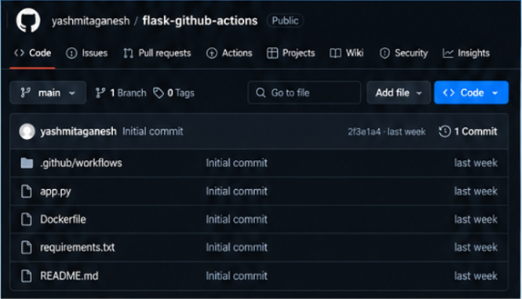
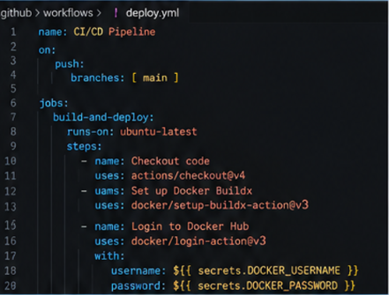
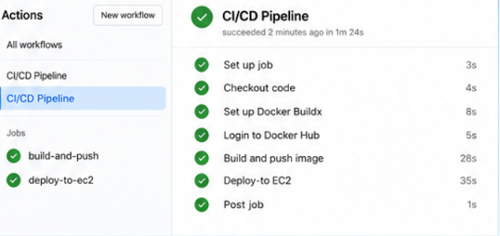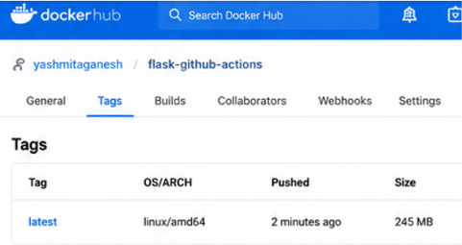
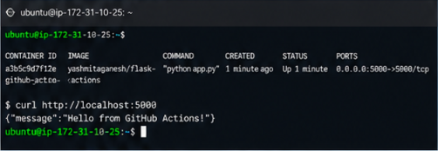
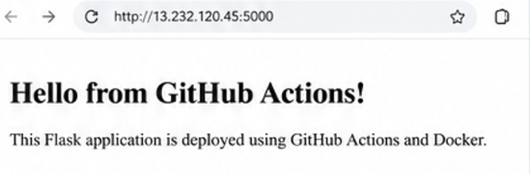

IMPLEMENTATION DETAILS
Parameter | Value
Repository | yashmitaganesh/flask-github-actions
Workflow | CI/CD Pipeline
Trigger | Push to main
Containerization | Docker
Registry | Docker Hub
Docker Image | yashmitaganesh/flask-github-actions:latest
Deployment Target | Cloud server / EC2
Application | Python Flask
Application Port | 5000
Deployment Status | Successful

GITHUB ACTIONS WORKFLOW
name: CI/CD Pipeline
on:
push:
branches: [ main ]
jobs:
build-and-deploy:
runs-on: ubuntu-latest
steps:
- name: Checkout code
uses: actions/checkout@v4
- name: Set up Docker Buildx
uses: docker/setup-buildx-action@v3
- name: Login to Docker Hub
uses: docker/login-action@v3
with:
username: ${{ secrets.DOCKER_USERNAME }}
password: ${{ secrets.DOCKER_PASSWORD }}
- name: Build and push image
uses: docker/build-push-action@v6
with:
push: true
tags: yashmitaganesh/flask-github-actions:latest
- name: Deploy
run: echo "Deploy application to cloud server"

OUTPUT
The GitHub Actions workflow successfully checked out the repository, configured Docker, built and pushed the Docker image, and completed the deployment stage. The Dockerized Flask application was accessible from the deployment environment.

RESULT
Thus, continuous deployment was successfully implemented using GitHub Actions and Docker. The application was automatically built, containerized, published, and deployed after a change was pushed to the main branch.

CONCLUSION
The experiment demonstrates an automated software delivery workflow in which GitHub Actions coordinates Docker image creation and deployment, reducing manual build and deployment effort.

